|  |  |
| --- | --- |
| C:\Users\BLynch\AppData\Local\Microsoft\Windows\INetCache\Content.Word\x.jpg | This is a detailed checklist that can be sent out with staff to assess a Branch after a disaster. The assessors can check problem areas, jot down notes and take digital photos.  This document can also be used for small office facilities. |
| **Disaster Response Management**  ***2. Branch Re-Opening Checklist*** | 40-Labarre_Logo_jpg |

This document is developed by Labarre Associates, Inc. and shared as a public service.

In August 2016, the Labarre Associates office flooded with up to 8 feet of water. Approximately half the employees lost their homes. This document has been updated annually for the past 9 years and represents accumulated “Lessons Learned” and tips that we had to learn the hard way; through experience.

While this document intended for Branches, it can also be used for small office buildings. Large office buildings require a team of Assessors including Architects, Engineers and Contractors and are beyond the scope of this document.

**© 2017, Labarre Associates, Inc.**



More than just design/build experts, **Labarre Associates** provides a turnkey solution- from site acquisition, design, construction, and facility management for financial institutions, state and local governments, and commercial clients. Our trusted approach has allowed us to successfully construct practical, functional, and purpose-built environments for the well-being of every individual. For over 35 years, our experience in this multifaceted industry has allowed us to simplify and streamline our process to provide uncompromising quality. **We don't just promise, we deliver.**

For more information concerning Labarre Associates, Inc. please visit the Labarre Associates website: [www.labarre-inc.com](http://www.labarre-inc.com) or call Angela Cannon at 225.664.1934.

\*\*This document can also be found on our website

Table of Contents

[Your Mission 3](#_Toc491949628)

[Key Points 3](#_Toc491949629)

[This document is intended to be used in conjunction with its sister documents: 4](#_Toc491949630)

[How to use this document: 4](#_Toc491949631)

[Trip Preparation: 5](#_Toc491949632)

[1. SITE 6](#_Toc491949633)

[2. BANK EQUIPMENT 6](#_Toc491949634)

[3. BRANCH 7](#_Toc491949635)

[A. EXTERIOR 7](#_Toc491949636)

[B. INTERIOR 7](#_Toc491949637)

[i. For interiors with no noticeable Water Intrusion: 8](#_Toc491949638)

[ii. For interiors that have received flood water: 8](#_Toc491949639)

[3. VENDORS 10](#_Toc491949640)

# 

# Your Mission

* To visit the Branch to document the extent of the damage.
* To provide a photographic record for insurance efforts as well as to communicate the condition to appropriate staff members.
* When encountering people bring a smile. If you see a guy walking by with nothing but the clothes on his back, bring him a cold water. You will never meet a more appreciative person in your life.

# Key Points

* There should be one person in charge of all assessment, demo and reconstruction. You don’t want demo to begin before you have finished your assessment.
* There will be massive traffic jams everywhere after a disaster (from 6:00 AM till midnight). Don’t waste a half day driving to a nearby Branch just to confirm it has flooded. Make your visit productive – use this document. When planning a trip, multiply the usual drive time by a factor of 5 or more. You need two people to do the assessment and should visit the location twice – once during the day and once at night (to properly evaluate site lighting).
* Don’t Rush the rebuild process. If you move in too soon you may end up with mold or a swampy smell that will never go away. A year after the Louisiana floods, many businesses that were the first to re-open are completely rebuilding their buildings -on their own nickel. They spent their insurance money foolishly. See the sister article in this series for “Quick Branch after the Flood” for an economical alternative to modular Branches, which will be in short supply.
* Contact your insurance company as soon as you have verified there is damage.
* Write flood height on the wall of each room. Leave the adjacent vertical section intact. Photograph the flood height with a tape measure next to it and another further back showing a person with the tape measure.
* Check your records to make sure there is no asbestos or lead paint (pre 1978 facilities).
* Employees may not be thinking clearly. Make sure they bring this checklist and items on the “what to bring list.”

# This document is intended to be used in conjunction with its sister documents:

* “Lessons Learned,”
* “Quick Branch after the Flood”

# How to use this document:

* Distribute to staff who will assess Branches
* Staff to note problems and take record photos (Time and date stamped)
* If there is damage on the exterior take time and date stamped photos
* For interior damage take at least 4 photos of each damaged room making sure to include floor and ceiling. Time stamp photos.
* Use these assessments to deploy resources and plan repairs.
* Most assessments will require a daytime and nighttime visit (to check lighting and signs).
* Assessment requires two people (to check lights etc. and for safety purposes)
* **LEAD!**

# Trip Preparation:

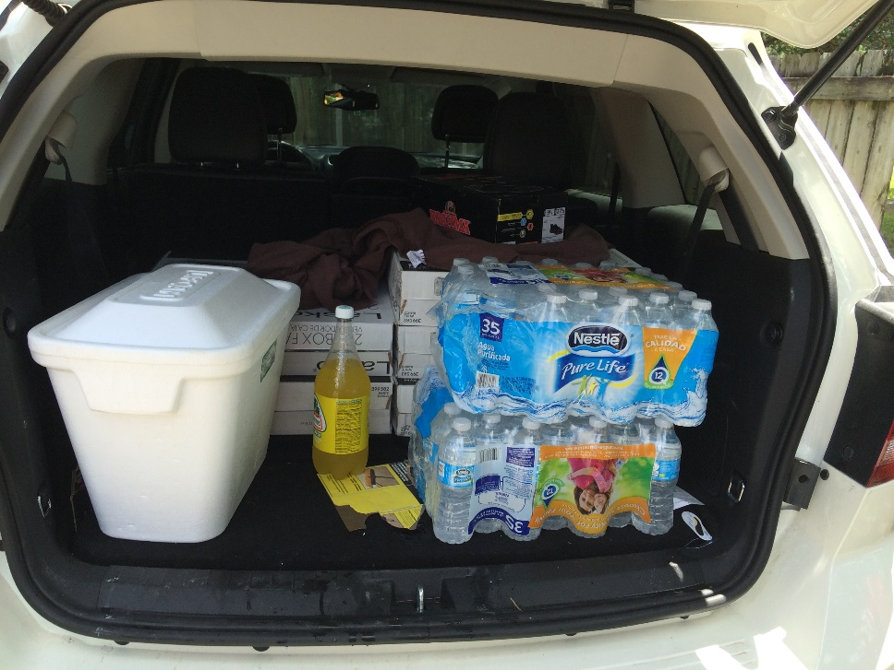

**Figure 1 – Bring supplies with you when you visit the Branch**

* When you are driving around immediately after a disaster, don’t assume you can “gas up on the way.” Gas stations in a flooded area are often closed because of the possibility of co-mingled water and gas.
* Two people teams
* Clip board, paper and pencil for taking notes plus a print out of this checklist
* If you bring a laptop, you need to bring a counter or portable stand.
* Bring car Cell phone charger.
* Bring a wall outlet cell phone charger with a LED to check for power.
* Don’t plug a laptop into a wall outlet without a surge protector anywhere.
* Tape Measure (Extra Wide, at least 16 feet)
* First Aid kit
* Case of Clorox wipes
* Tool belt (to put your tape measure, pencils, chargers etc.
* Water, ice, two meals for each person (at least) and a cooler. Keep in mind that most fast food restaurants will be closed and those that are open will have extensive lines all the time and will be serving a limited menu.
* Rubber gloves and a bottle of hand sanitizers
* Indelible markers (i.e. Sharpie)
* Bring two pairs of shoes. Steel toed shoes are recommended for the site visit. Bring plastic bags with you. Put the shoes you wore at the site in the bag before re-entering your vehicle. Bring comfortable shoes with you for the vehicle ride. You should be able to comfortably walk 5 miles in these shoes. Consider bringing a change of clothes – there can be mud everywhere.

# 1. SITE

**🞎 Freestanding, lighted identity signs** – verify power to sign is working and sign is not cracked or scratched (night)

**🞎 Wall-mounted identity signs –** verity power to sign is working and sign is not cracked or scratched (night)

**🞎 Site circulation and information signs –** verify that they are firmly attached to ground.

**🞎 Fences -** Push fences to make sure the supports are not sheared off or split. Check for damage behind bushes.

**🞎 Catch basin inlets (holes in curb for drainage).** Check to ensurethe inlet and basin (inside) are not obstructed.

**🞎 Visually scan adjacent street for signs of flooding.** Report blocked drainage paths to the authorities.

**🞎 Light poles.** Carefully push poles to make sure they are sturdy and bolts are not sheared off.

**🞎 Site and Exterior Building Lights –** Pole lights, wall packs, flood lights, ground flood lights (Inspect for operation at night).

**🞎 Trees -** Inspect for hanging limbs.

**🞎 Chain Saws -** Any employees operating chain saws should have appropriate OSHA training and wear appropriate personal protective equipment (chaps, leather gloves, hard hat with face guard, appropriate vest).

**🞎 Avoid downed power lines.** Do not drive over downed lines. Call Power Company to report downed lines.

**🞎 Directional Signage –** Verify that all signs are still in place or not blown over. Closely examine signs for dents and damage.

# 2. BANK EQUIPMENT

**🞎 Lane “Open and Closed” and ATM lights.** Switch open/close and on/off (Have someone outside checking operation).

**🞎 Drive thru canopy lights -** check at underside of canopy.

**🞎 VAC (RTU) Units –** gently push against units to make sure they are still firmly attached. Inspect overhead tubes for cracks and attachment. Check VAC/ RTU unit operation after inspection. Clean if needed.

**🞎 Drive Thru Window –** Wash (if needed)

**🞎 Drive Thru Structure –** Check (columns/ framing) for signs of damage

**🞎 Drive Thru Roof –** Check for signs of damage (missing shingles or portions of the roof, dented metal roofing, drips from underside, punctured flat roof).

**🞎 Underside of Drive Thru Structure - check** for signs of water leaks. Check drive thru lanes for tell-tale drip marks from water leaks that are not visible.

**🞎 ATM –** Check Operation and check unit for damage or signs of water intrusion. Check operation with test card. Clean if needed (Windex and a rag).

**🞎 Night Deposit -** Check interior for signs of water intrusion. Clean if needed.

**🞎 Deal Drawer** - Check interior for signs of water intrusion and exterior for damage.

**🞎 Vault –** Some times the building will flood, but the vault doesn’t take on water. Check for water stains or standing water in the vault. Just because your building flooded, doesn’t mean your vault flooded. Get your vault vendor to check vault operation.

**🞎 Undercounter steel –** open doors. Set up on blocks. Empty drawers**.**

# 3. BRANCH

## **A. EXTERIOR**

**🞎 HVAC Units -** Clear debris from exterior HVAC unit(s) and immediate area. Hose down units to remove straw, mulch and leaves from the side or top of unit. Check for dents and that unit is sitting properly on base and not loose.

**🞎 Exterior Walls, Columns, Eaves and Windows -** Check for signs of damage.

**🞎 Shingle, Slate and Metal Roofs –** Complete visual inspection from the ground for dents, missing shingles, and other signs of damage. Asphalt shingles that show damaged corners, loss of grit, dents and visible fiberglass threads are likely indicators of failure. Verify that all visible flashing is not damaged. Consult warranty before contacting a roofer for repairs. Photo record of all damage is required.

**🞎 Flat Roof –** Visually inspect parapet coping for damage. If there is no apparent water leakage on the interior or underside of the drive-thru, no further action is required. If there is interior water damage, and the roof is accessible, check the roof for blocked drains and scuppers. Inspect the roof for cuts, dents and other problems with the membrane. Remove all limbs and foreign objects from the roof. Only walk in areas designated for foot traffic. Consult warranty before contacting a roofer for repairs. Photo record of all damage is required.

**🞎 Gutters and downspouts –** Visually survey gutters and downspouts for signs of damage or blockage.

**🞎 Temporary Signage –** you might want to consider temporary signage directing customers to the nearest open Branch. Include your call center number.

## **B. INTERIOR**

**🞎 Power –** Look at electric meter to determine if there is live power to the building. Spinning wheel indicates power, even if all lights are off. If the surrounding area has power and your building does not, the problem may be a severed connection with the main line. An electrician may be able to troubleshoot your problem and get you up and running sooner than the electric company.

**🞎 Breaker Panel -** Check breaker panel for tripped circuit breakers. Reset if needed. Write down indicators of possible loss of power (blinking thermostat, clocks with the wrong time etc.). Relay this information to appropriate departments for equipment recalibration (IT, Security, Bank Ops etc.).

**🞎 Communication Lines –** Verify that phone, computer and power lines are in operation. Note: security system requires both power and phone connections.

**🞎 Plumbing –** Turn on faucets in rest room, break room and janitor’s closet. Turn on exterior hose-bibs. Run water for an extended period, check samples for discoloration. Smell the water for unusual odors. Check that hot water is working. Take appropriate actions (i.e. re-light pilot light on water heater) if needed. Check operation of toilets.

**🞎 Furniture –** Note whether furniture received flood water. Comment on whether you think it is reusable. If you have, for example, a book case that is made out of solid wood (not laminate or particle board), it may be salvageable.

### **For interiors with no noticeable Water Intrusion:**

**🞎 Ceiling Tiles –**Ceiling tiles should be examined for signs of dampness or water spots. Fiberglass insulation above ceiling tiles should also be checked for moisture. All wet tiles and insulation should be removed from the building immediately and placed in the dumpster. Remember that water often takes a circuitous route from the source of the leak.

**🞎 Doors –** Floors at doors should be inspected for signs of wind-driven water intrusion. Use janitor mop and bucket to remove water from all floor surfaces.Pull back wet carpet and install fans to dry out carpet and floor.

**🞎 Baseboards –** Check area below drive-thru window and other windows for signs of water intrusion (may be under carpet).

**🞎 Window Sills –** Visually inspect for signs of water intrusion (puddles, water stains)

**🞎 Interior Air Handling Unit –** Check inside and exterior for water intrusion. Write down description of any noises that may be a sign of problems. Take a video of a unit that sounds funny.

**🞎 Thermostats –** Verify settings are programmed correctly. Reprogram if blank or blinking. Coordinate settings with branch manager. Count exterior Heat Pumps and make sure a like number of interior thermostats have been reprogrammed. After checking Exterior Units, turn on each unit and check operation.

**🞎 Interior lights –** Check for burned-out bulbs or operation problems.

**🞎 Flooring - Check** for signs of water or leaks

### **For interiors that have received flood water:**

**In addition to items in the no flood section above, the following should be checked:**

**🞎** Note the flood height in each room (write it on the wall). Leave one vertical section of wall in each room (with flood height) intact. Photograph the flood height with a tape measure next to it and another further back showing a person with the tape measure.

|  |  |
| --- | --- |
| **C:\Users\BLynch\AppData\Local\Microsoft\Windows\INetCache\Content.Word\IMG_0433.jpg**  **Figure 2 - Use a permanent marker to note the water height in each room. Photograph the mark along with a tape measure showing the height.** | **C:\Users\BLynch\AppData\Local\Microsoft\Windows\INetCache\Content.Word\IMG_0432.jpg**  **Figure 3 - Leave one vertical section that includes the wall material and base board as well as special conditions (built-in shelves). Step back and take a photo showing the wall and tape measure. Use high resolution photographs.** |

**🞎Photographs – Don’t forget to turn on the “Time Date Stamp”**

**🞎 Note whether the floodwater was “clean water”** from the parking lot or dirty, silt-laden water. Note, the dirty water will leave a deposit of silt on everything. This is an important distinction, because the Flood Adjuster will not want to allow replacement of ceramic tiles or stone flooring. If the flood water was “clean” this might be acceptable. If you leave ceramic tiles or similar flooring after a “dirty” flood. The grout will absorb the smells of the flood (diesel fuel, sewage (yes) and dead fish unless you remove and replace. Your building will smell like a swamp forever and you will never be able to figure out where the smell is coming from.

**🞎 HVAC** – If you have no HVAC, promote air circulation by opening windows and running fans. If your windows don’t open, and there is no AC you might consider removing a few.Keep HVAC running 100% to dry out the structure. Both heat and air conditioning work to wring the water out of the air. If you have an exterior unit that was flooded and an interior air handler that was not, you might only have to replace the exterior unit (condenser and compressor) and coils (this is a rectangular package that is inserted in the air handler and is made to be replaced). If your exterior unit was flooded and the circulating fan works, you can most likely use the heat.

**🞎 Fans –** distribute circulating fans throughout the structure. Don’t forget to bring extension cords.

**🞎 Documents** – contact a specialty contractor for document recovery. This typically has to happen off site. If you have to do it yourself, freeze wet documents, then separate as they thaw.

**🞎 Mold –** you have 48 hours after the floodwater recedes to open up your walls and, get the air circulating in the wall cavities to prevent mold. In order to accomplish this, it means you usually have to do this yourself, or if you are lucky, you will have a maintenance contractor. If you don’t have the resources, line up contractors while the flood is happening. Remember that many of your “go to” contractors, like painters or landscapers may be willing to help with demo.

**🞎 Paintings, items of value –** You may want to remove to a safe place for storage as drywall in each room will be removed. Photograph and document before removing. A full list will probably be on an asset list in accounting.

**🞎 Furniture and Equipment** – Salvageable equipment should be moved to a safe, conditioned storage place. Generally speaking, solid wood furniture can be cleaned up and reused.

**🞎 Demolition** – while it is imperative to get the sheetrock off the walls within 48 hours you can take a little longer to clean out the building. Most jurisdictions have a free debris pick-up, but require all debris (including equipment like refrigerators) to be within 8 feet of the road. If you place a refrigerator in the debris pile, make sure the door is secured to prevent children from climbing in. All debris and furniture should be removed from the building. Small safes, night drop and drive thru equipment can usually stay in the facility.

**🞎 Drying out period –** Depending on the season and your climate, your facility will require a drying out period. In the deep south, this could be several months. Get a moisture reader before rebuilding. If you rebuild too soon, you may be rebuilding twice.

**🞎 Dehumidifier -** You might want to purchase multiple dehumidifiers for each branch. Hook them up to a hose that will drain to the exterior because they fill up in a couple of hours. Order on line for in-store pick up at your local supply store.

**🞎 Mold treatment** – Consult your remediation consultant or contractor. You might also want to test for mold before and after the treatment.

# VENDORS

**Contact all vendors that regularly service the Branch (cleaning, ATM restock and so on) and advise them of the situation. They may be able to supply labor for demo (the cleaning contractor is probably your best bet).**

**🞎 Insurance Company –** Record all expenses, including loss of revenue associated with disaster closure. Have a copy of your policy readily available and report damage noted above to your insurance company. Call them as soon as you know the situation and they will schedule an adjuster to visit. Failure to do this in a timely manner will put you at the “end of the line” and you may have a considerable wait.

**🞎 Cleaning/ Dumpster** - Contact the cleaning and waste removal vendors to inform them about reopening schedule and verify that service will be restored.

**🞎 Security -** Contact Security Vendor with reopening schedule. Phone and power are typically required for operation of the security system. Have cell phone ready and vendor contact information available at re-entry.

**🞎 Landscape –** Work with Landscape vendor to restore lost planting beds and removal of downed limbs and trees. At current contract negotiations, insist that you be listed in their priority list for after disaster response. Negotiate a fair rate and response time. Remember that after a disaster, they are focused on a lucrative line of temporary work – tree removal and trimming.

**🞎 HVAC –** Make sure someone from your staff is available to meet the contractor at the site. Explain exactly what the problem is during your request for service.

**🞎 Mud –** Where there is mud or debris in the parking lot, contact the pressure wash vendor to pressure wash the impacted areas.

**🞎 Roofer –** Warranties should be readily accessible before and after the storm. Rely on your architect for advice in this area. Repairs that are not completed as specified in the warranty can void the warranty. Typically, slate roofs are the quickest to repair and shingles can be replaced as soon as replacements are located. Asphalt shingle roofs can be patched as soon as they are dry. Flat roofs must be completely dry before repair. If there has been water intrusion, the wet areas must be cut out and replaced. Metal roofs typically take the longest time to repair as materials must be ordered from the factory.

**🞎 Mold Treatment -** Flooded buildings need to be treated for mold.

**🞎 Signage** – report any sign damage.

\*\* A downloadable version can be found on our website