|  |  |
| --- | --- |
|  | This document provides a case study of a temporary Branch that was built in two weeks. Strategic questions about rebuilding are included to guide your analysis of rebuild options. |
| **Disaster Response Management**  ***3. Quick Branch & Rebuild*** | 40-Labarre_Logo_jpg |

In August 2016, the Labarre Associates Denham Springs office flooded with up to 8 feet of water. Approximately half the employees lost their homes. In Denham Springs, virtually every structure was flooded. 9,000 out of 10,000 residents had to be evacuated. Only one financial institution survived.

After working together for decades, Labarre Associates and the management staff at Pelican State Credit Union met to strategize how to get the Denham Springs Branch re-opened. This document explains the creative solution that was devised. This approach is particularly important for Financial Institutions in flooded areas as Modular Branches may be in short supply.

**© 2017, Labarre Associates, Inc.**



More than just design/build experts, **Labarre Associates** provides a turnkey solution- from site acquisition, design, construction, and facility management for financial institutions, state and local governments, and commercial clients. Our trusted approach has allowed us to successfully construct practical, functional, and purpose-built environments for the well-being of every individual. For over 35 years, our experience in this multifaceted industry has allowed us to simplify and streamline our process to provide uncompromising quality. **We don't just promise, we deliver.**

For more information concerning Labarre Associates, Inc. please visit the Labarre Associates website: [www.labarre-inc.com](http://www.labarre-inc.com) or call Angela Cannon at 225.664.1934.

\*\*This document can also be found on our website

Table of Contents

[Key Point 2](#_Toc492024143)

[This document is intended to be used in conjunction with its sister documents: 2](#_Toc492024144)

[1. Concept 3](#_Toc492024145)

[2. Design & Construction 4](#_Toc492024146)

[3. Re-Opening with Temporary Branch 7](#_Toc492024147)

[4. Re-Opening – Remodeled Branch 8](#_Toc492024148)

[5. Value Proposition 9](#_Toc492024149)

[6 Strategic Questions 10](#_Toc492024150)

# Key Points

Total Cost (Capital and Expense) of the Quick Branch can be half that of Modular.

The design/ construction process for the Branch can be condensed to two weeks.

Re-Open a temporary Branch as soon as possible, then take time for evaluation and study of your rebuild/ relocate options.

# This document is intended to be used in conjunction with its sister documents:

* “Lessons Learned,”
* “Branch Re-Opening checklist

# 1. Concept

|  |  |
| --- | --- |
| The Pelican State Credit Union’s Denham Springs Branch was inundated with three feet of water during the great flood of August, 2016. A large percentage of Credit Union and Labarre employees were homeless and it took two weeks to gather a group for a Brainstorming Session. | #louisianastrong #louisianaflood #prayforlouisiana #rebuild #louisiana #livingstonparish #thegreatflood: |
| Pelican State had a contract for temporary ATM’s to be delivered after a disaster and the trailer-based ATM’s were set up soon after the floodwaters receded. |  |
| The Brainstorming session started with a discussion of how to accommodate a waiting line because the “emergency Branch truck” had only two desks. **When it was suggested that the covered Drive-Thru could serve as a waiting area, Jay Labarre said “I can do better and we can convert the Drive Thru to a temporary Branch!”** | C:\Users\BLynch\AppData\Local\Microsoft\Windows\INetCache\Content.Word\IMG_0571.jpg |

# 2. Design & Construction

|  |  |
| --- | --- |
| Jay, who is President and CEO of Labarre Associates did a quick concept sketch based on one desk in each Drive Thru lane. |  |
| The sketch at the right shows the temporary enclosure in red. A “verbal” building permit was issued by the Building Inspector. |  |
| A removable wood frame was erected around the perimeter of the Drive Thru. | C:\Users\BLynch\AppData\Local\Microsoft\Windows\INetCache\Content.Word\IMG_0910.jpg |
| Translucent fiberglass panels were screwed to the wood frame for easy removal. Doors were installed immediately and were not painted. | C:\Users\BLynch\AppData\Local\Microsoft\Windows\INetCache\Content.Word\IMG_0573.jpg |
| As construction started on the temporary Branch, the interior drywall was gutted to five feet and doors and flooring were removed. Note existing bank equipment was reconditioned and used to support the temporary Branch. | C:\Users\BLynch\AppData\Local\Microsoft\Windows\INetCache\Content.Word\IMG_7627.jpg |
| HVAC was diverted from existing HVAC units to the Drive Thru. | C:\Users\BLynch\AppData\Local\Microsoft\Windows\INetCache\Content.Word\IMG_0557.jpg |
| Toilet facilities within the Branch were cleaned up and re used. A 6-foot fence provided a secure path to the Branch interior. Existing Safes and Bank Equipment within the Branch were used. | C:\Users\BLynch\AppData\Local\Microsoft\Windows\INetCache\Content.Word\IMG_0572.jpg |
| A temporary teller line was built out of Plywood. There was no need for additional lighting as the walls were translucent. | C:\Users\BLynch\AppData\Local\Microsoft\Windows\INetCache\Content.Word\IMG_7632.jpg |

|  |  |
| --- | --- |
| RTU units were left in place and reconditioned. The Plywood teller line was covered with carpet tiles and the laminate counter tops were purchased at a big box store. | C:\Users\BLynch\AppData\Local\Microsoft\Windows\INetCache\Content.Word\IMG_0561.jpg |
| Portable tables and blue plastic bins supported work and storage. | C:\Users\BLynch\AppData\Local\Microsoft\Windows\INetCache\Content.Word\IMG_0562.jpg |
| The check writing stand was an adjustable table and the waiting area was a bunch of chairs purchased from a big box retailer. | C:\Users\BLynch\AppData\Local\Microsoft\Windows\INetCache\Content.Word\IMG_0564.jpg |
| OSHA guidelines for trip hazards were observed as the drive thru islands were elevated. |  |

# 3. Re-Opening with Temporary Branch

|  |  |
| --- | --- |
| Signs and a media blitz alerted the public to the opening which occurred two weeks after the brainstorming session. |  |
| When the Branch opened, employees were stationed outside (with a portable cooler) to direct perplexed members to the Branch, which was “in Back” instead of “in front.” |  |
| Busy Branch in action. | C:\Users\BLynch\AppData\Local\Microsoft\Windows\INetCache\Content.Word\IMG_0552.jpg |
| Demo on the Branch started on a Friday evening and was finished by Saturday afternoon. | C:\Users\BLynch\AppData\Local\Microsoft\Windows\INetCache\Content.Word\IMG_0911.jpg |

# 4. Re-Opening – Remodeled Branch

|  |  |
| --- | --- |
| While the Temporary Branch was serving member needs, the Credit Union had time to carefully consider options for rebuilding. Based upon the insurance settlement and their Strategic Facility Plan, they decided to rebuild using their new Prototype that featured “Teller Pods” Instead of a “Teller Line.” | C:\Users\BLynch\AppData\Local\Microsoft\Windows\INetCache\Content.Word\IMG_3014.jpg |
| Cash Recyclers provided security allowing free movement around the “Teller Pod.” A Teller Work area is provided behind the screen and includes storage for supplies, a work surface, stool and personal computer | C:\Users\BLynch\AppData\Local\Microsoft\Windows\INetCache\Content.Word\IMG_3012.jpg  **CASH RECYCLER**  **TELLER WORK AREA** |
| A Tech Center provides collaboration, research and consultation space. Tellers can easily move the “Teller Pods” to the Tech Center to collaborate with members. | C:\Users\BLynch\AppData\Local\Microsoft\Windows\INetCache\Content.Word\IMG_3016.jpg |
| **Time Line**  **Temporary Branch**  2 Weeks | **Time Line**  **Branch Renovation**  3 Months from start of Construction |

# 5. Value Proposition

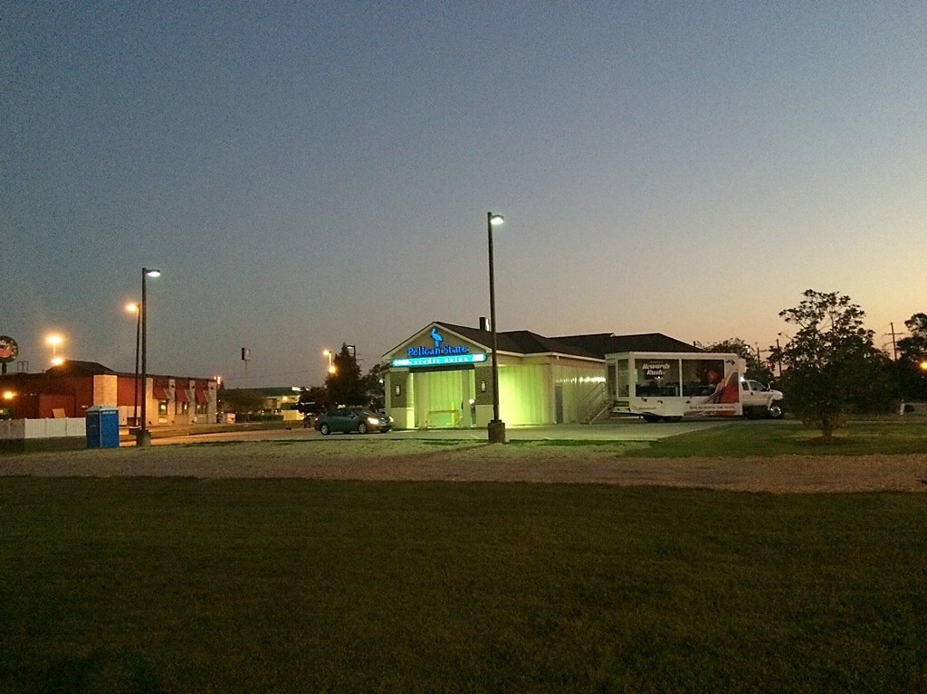

OVER FLOW PARKING

The Branch was so successful, overflow parking had to be added. Because the Branch was located adjacent Home Depot Drive, it was at the epicenter of the rebuilding effort in Denham Springs. The “glowing Branch” became a conversation topic and many people stopped in “just to see what was inside.”

**Total Cost (Capital and Expense) of the Quick Branch can be half that of Modular:**

The value proposition starts with the capital cost that is about twice what you would expect to pay in lease expense for a modular Branch over a year. However, a modular Branch has a delivery & return charge (usually more than $10 per mile per section), set-up/ break down fees and expenditures for ramps and porches. Temporary utility connections and other miscellaneous expenses can run the total operating and capital cost impact to twice the amount of the enclosed drive thru. The only operating cost impact for the quick Branch was an increased utility bill and an on-site security guard.

# 6 Strategic Questions

After a Branch has been damaged in a disaster, the first inclination is to rebuild and reopen as soon as possible. We would like to pose some strategic questions that only you can answer, and which will guide your decision-making.

* Are you happy with your Branch design? What would you change?
* Is your overall Branch network where you want it to be? Do you have a poor performer you may want to close? Would a new location more efficiently serve the closed and damaged Branches?
* If you rebuild will you be “upside down” on your Branch? To determine this, add the rebuild cost to your book value, include any anticipated Facility Renewal expenditures (i.e. new roof) and compare this total to the Market Value (provided by your Broker through a Broker’s Price Opinion or Appraisal).
* Are there any prime retail locations that are available after the disaster?
* How long will the population around your Branch location be depressed? Will there be enough traffic to warrant keeping the Branch open?

Every disaster is unique and every financial institution has a special set of circumstances. Based on our experience we would recommend that you get a damaged Branch up and running as soon as possible in a temporary structure, then see what happens. You will then have real time intelligence from your staff and you will have the time to carefully consider your options.

\*\*This article can be found on our website